Rockets!

History:
Who was Dr. Robert H. Goddard?,

What was he the first to do in 1926? (Did you catch that? 1926!!!)

How far and for how long did the rocket named "Nell" fly?

What are 3 other of Dr. Goddard’s “firsts” before 1940?

What did Homer Hickam and the Rocket Boys of Big Creek High School do?

Were they immediately successful? Explain.

Forces of Flight:
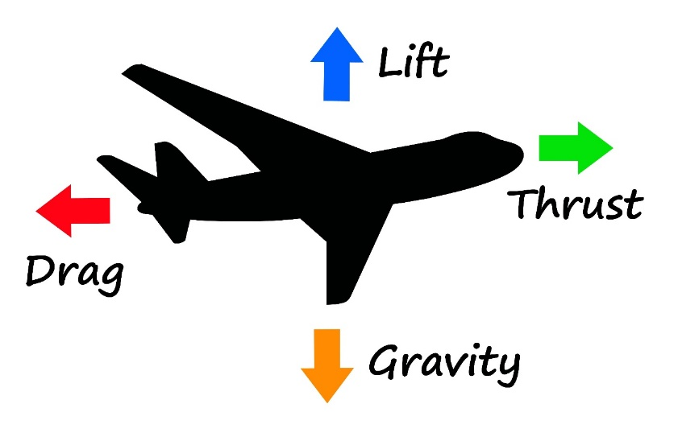
For an airplane (or a rocket) to become airborne, which force must overcome the which other force?

For a plane to move forward, which force must overcome the which other force?

What provides these forces?
Lift - Gravity –

Thrust – Drag –

In a rocket, what provides these forces?
Lift –

Gravity –

Thrust –

Drag –

Newton’s Laws:
Define (include the rocket example):
Law 1 –

Ex.

Law 2 –

Ex.

Law 3 –

Ex.

Model Rocket Flight:
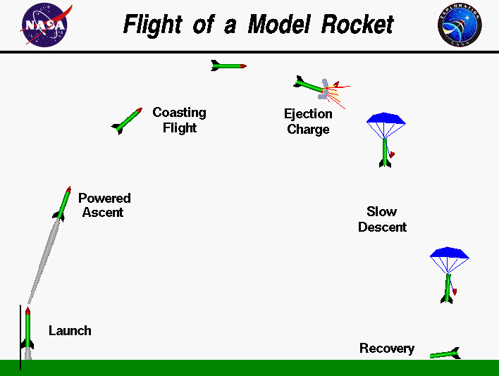
At launch, why does a rocket accelerate away from the launch pad?

What other forces are also acting on a rocket?

Why does a rocket coast and then slow down?

What brings the rocket back down to earth?

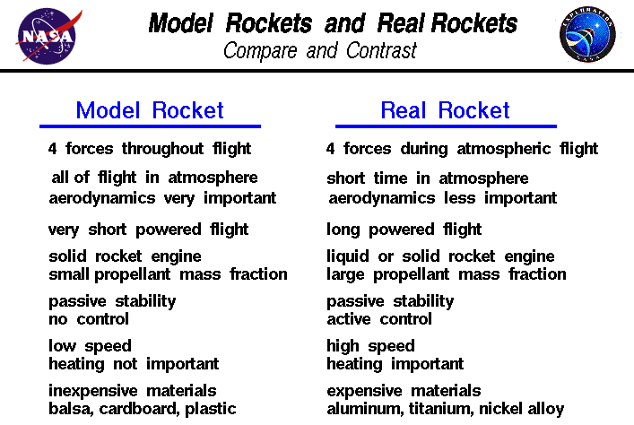
What is something real rockets and model rockets have in common?

What are 3 things that are different between real rockets and model rockets?

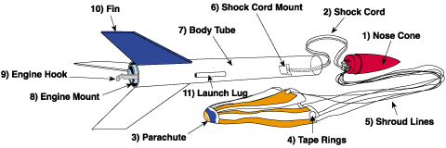
Parts of a Model Rocket:
Describe the different parts of a Model Rocket:
1) Nose Cone:

2) Shock Cord:

3) Parachute:

4) Tape Rings:

5) Shroud Lines:

6) Shock Cord Mount:
7) Body Tube:

8) Engine Mount:

9) Engine Hook:

10) Fin:

11) Launch Lug:

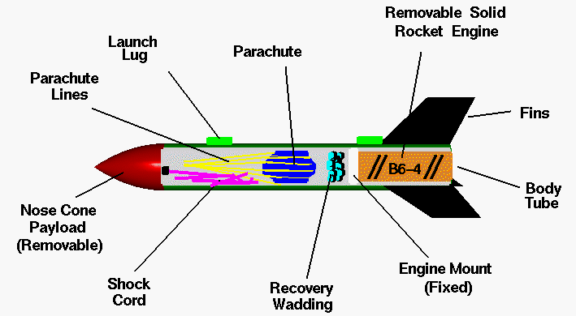
Other Parts:
Engine:

Recovery wadding:

Model Rocket Engine:
What are engines made out of?

What is inside the engine?

What is the nozzle used for? What is it made of? Why?

What causes the rocket to stop accelerating? What else is there so you can find your rocket easier?

What causes the parachute to be deployed?

