Name: ____________________________________________________ Core: __________

Phases of Meiosis

Name of Phase | Description
Interphase
Prophase I
Metaphase I
Anaphase I
Telophase I
Cytokinesis
Interphase
Prophase II
Metaphase II
Anaphase II
Telophase II
Cytokinesis
Results of Meiosis:

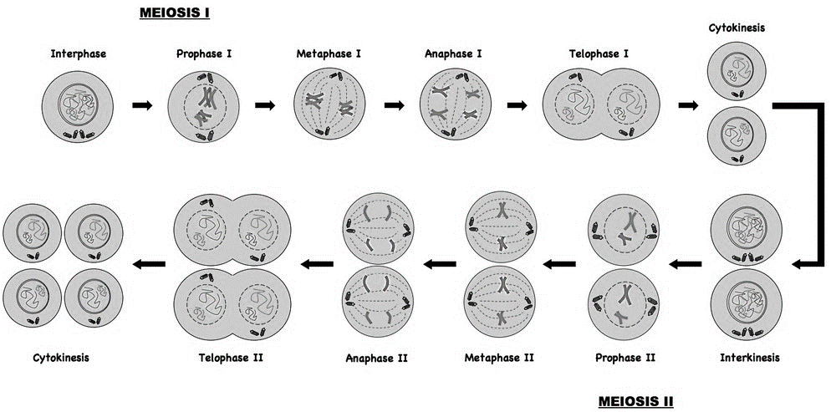
Label the diagrams below, using the terms from the table above.

Mitosis / Meiosis 3-2-1
What are 3 ways Mitosis and Meiosis are different?

What are 2 ways Mitosis and Meiosis are the same?

What is 1 reason we need Mitosis and Meiosis?

