Name: ________________________________________________________________ Core: ________

Roller Coasters: Measuring Acceleration

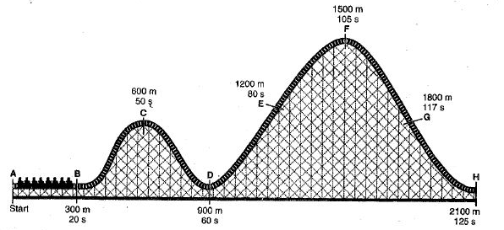

1) Study the roller coaster shown above. At each lettered point, the distance and time from the beginning of the roller coaster ride is shown. In the Data Table below, for each point, record the distance and time from the previous point.

2) Calculate the average velocity at each point using the distance and time from the previous point. Record your calculations in the Data Table below. (Show your work!)

3) In the graph provided, plot the average velocity at each point versus the total time elapsed at that point on the roller coaster ride. Connect the points. Don’t forget to show the values on the x and y axis.

Data Table
Point | Distance from Previous Point | Time Elapsed from Previous Point | Average Velocity
A
B
C
D
E
F
G
H

Graph

Velocity (m/s)

Time (s)
Acceleration
4) Copy the average velocity and time elapsed from the Data Table above into the chart below. Calculate the acceleration between each set of points, using the average velocity at that point as the final velocity, and the average velocity at the previous point as your initial velocity. For time, use the time elapsed between the two points. Record your calculations below.

Point | Average Velocity | Time elapsed from previous point | Acceleration
A
B
C
D
E
F
G
H

Analysis
1) Using the graph, between which sets of two points did the roller coaster accelerate? ____________________
__________________________________________________________________________________________
2) Between which sets did it decelerate? _________________________________________________________
__________________________________________________________________________________________
3) Between which two points was acceleration the fastest?________________ the slowest? ________________
4) Between which two points was deceleration the fastest? _______________ the slowest? ________________

